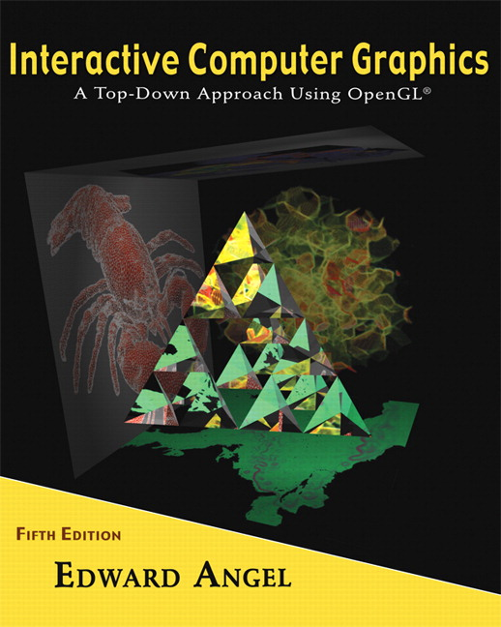 COSC 4370
Name: Terminal #

Programming Assignment 2 Hours:
Acceptance Testing Check Sheet:
V
X
?

Done Not Done In Between (add words comments)
CHECKLIST (YOU MUST CHECK BOXES YOURSELF!):

- SUBMITTED .zip PROJECT to BB?________________

- SUBMITTED PROJECT HARDCOPIES?(Screenshots + Source)___

- ACCEPTANCE TESTING Step 1?________ _______________

- ACCEPTANCE TESTING Step 2?________ ____________

- ACCEPTANCE TESTING Step 3?__________________________

- ACCEPTANCE TESTING Step 4?__________________________

- ACCEPTANCE TESTING Step 5?__________________________

- ACCEPTANCE TESTING Step 6?__________________________

- ACCEPTANCE TESTING Step 7?__________________________

10.ACCEPTANCE TESTING Step 8?__________________________

11.SUBMITTED Acceptance Testing .doc to BB_____ ___

I CERTIFY THAT THIS IS MY OWN WORK and THE CHECKBOXES reflect the completion of these DELIVERABLES.
SIGNATURE:

